Report: Spam Email Detection Web Application

1. Aim
The aim of this project is to design and implement a web-based application that can automatically classify emails as Spam or Non-Spam. The system uses machine learning models trained on a labeled dataset and allows users to upload PDF email files for real-time classification.

2. Introduction
Email spam is one of the most common security threats in the digital world. Spam messages may include advertisements, phishing attempts, or malicious links. Manually filtering spam is inefficient, hence the need for automated spam detection using machine learning.
This project focuses on:
- Preprocessing and cleaning raw email data.
- Converting text into numerical features using TF-IDF.
- Training machine learning models such as Naïve Bayes, Logistic Regression, SVM, and Random Forest.
- Developing a simple web-based interface using Gradio for classifying PDF emails as Spam or Non-Spam.

3. Implementation

a) Dataset
- The dataset contains 10,152 emails with the following fields:
  - label: Target column (1 = Spam, 0 = Non-Spam)
  - subject: Subject of the email
  - message: Body of the email
- Preprocessing steps included:
  - Handling missing values in subject and message.
  - Cleaning text (lowercasing, removing punctuation, stopwords, stemming, and lemmatization).
  - Combining subject + message into one column (clean_text).

b) Model Traning
- The clean_text column was vectorized using TF-IDF (max_features=5000).
- The dataset was split into 80% training and 20% testing.
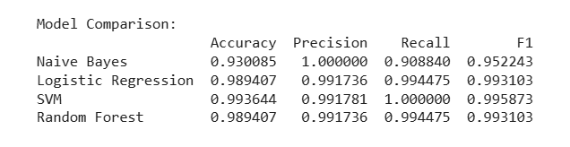
✅ The logistic regression model was chosen as the best performing model due to its high accuracy and precision.
c) Web Application
- The application allows users to upload a PDF email file.
- The system extracts the text using PyPDF2, processes it, and predicts Spam or Non-Spam using the trained SVM model.
- Implemented using Gradio for quick prototyping, allowing both single and batch PDF upload (bonus feature).

📸 Screenshots :
- Model training results (accuracy comparison table).
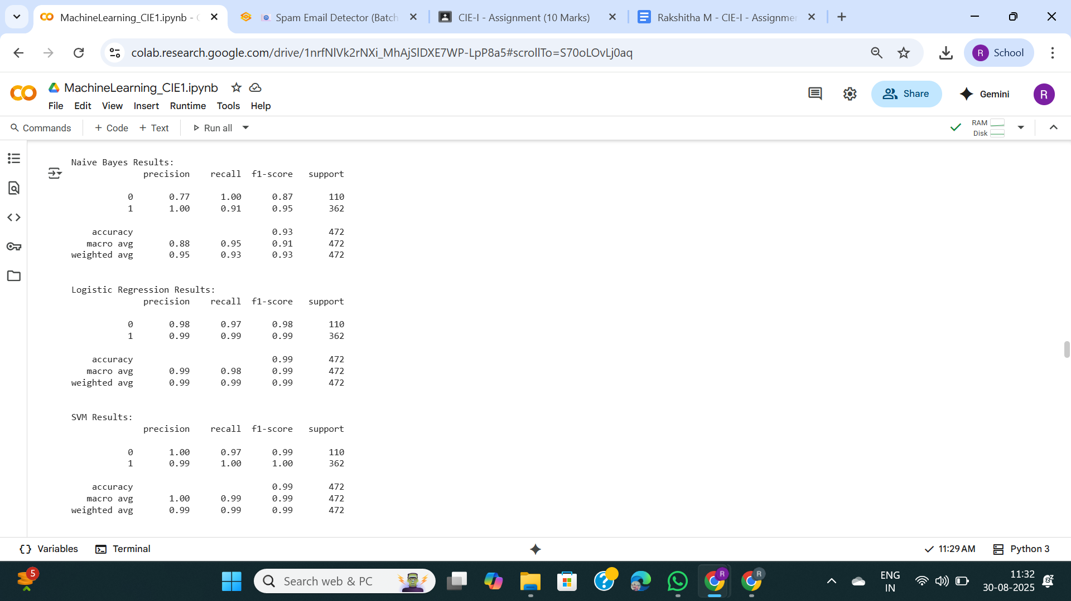

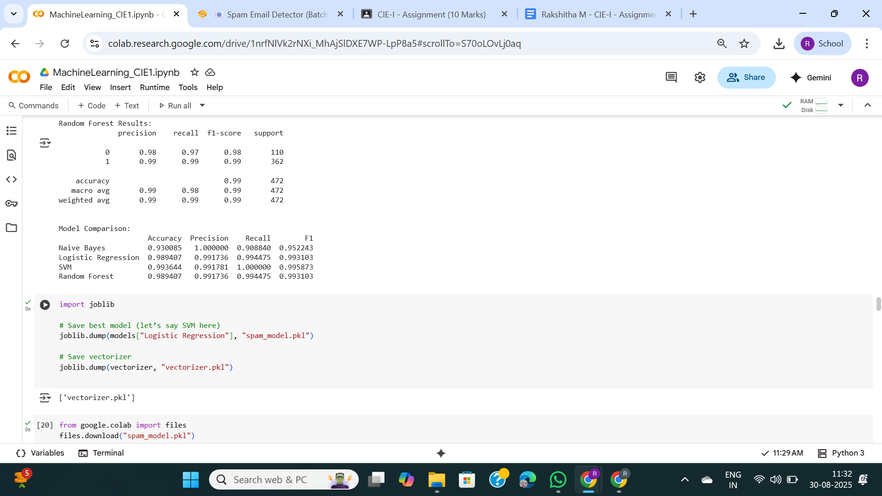

- Gradio web app interface (single PDF upload).
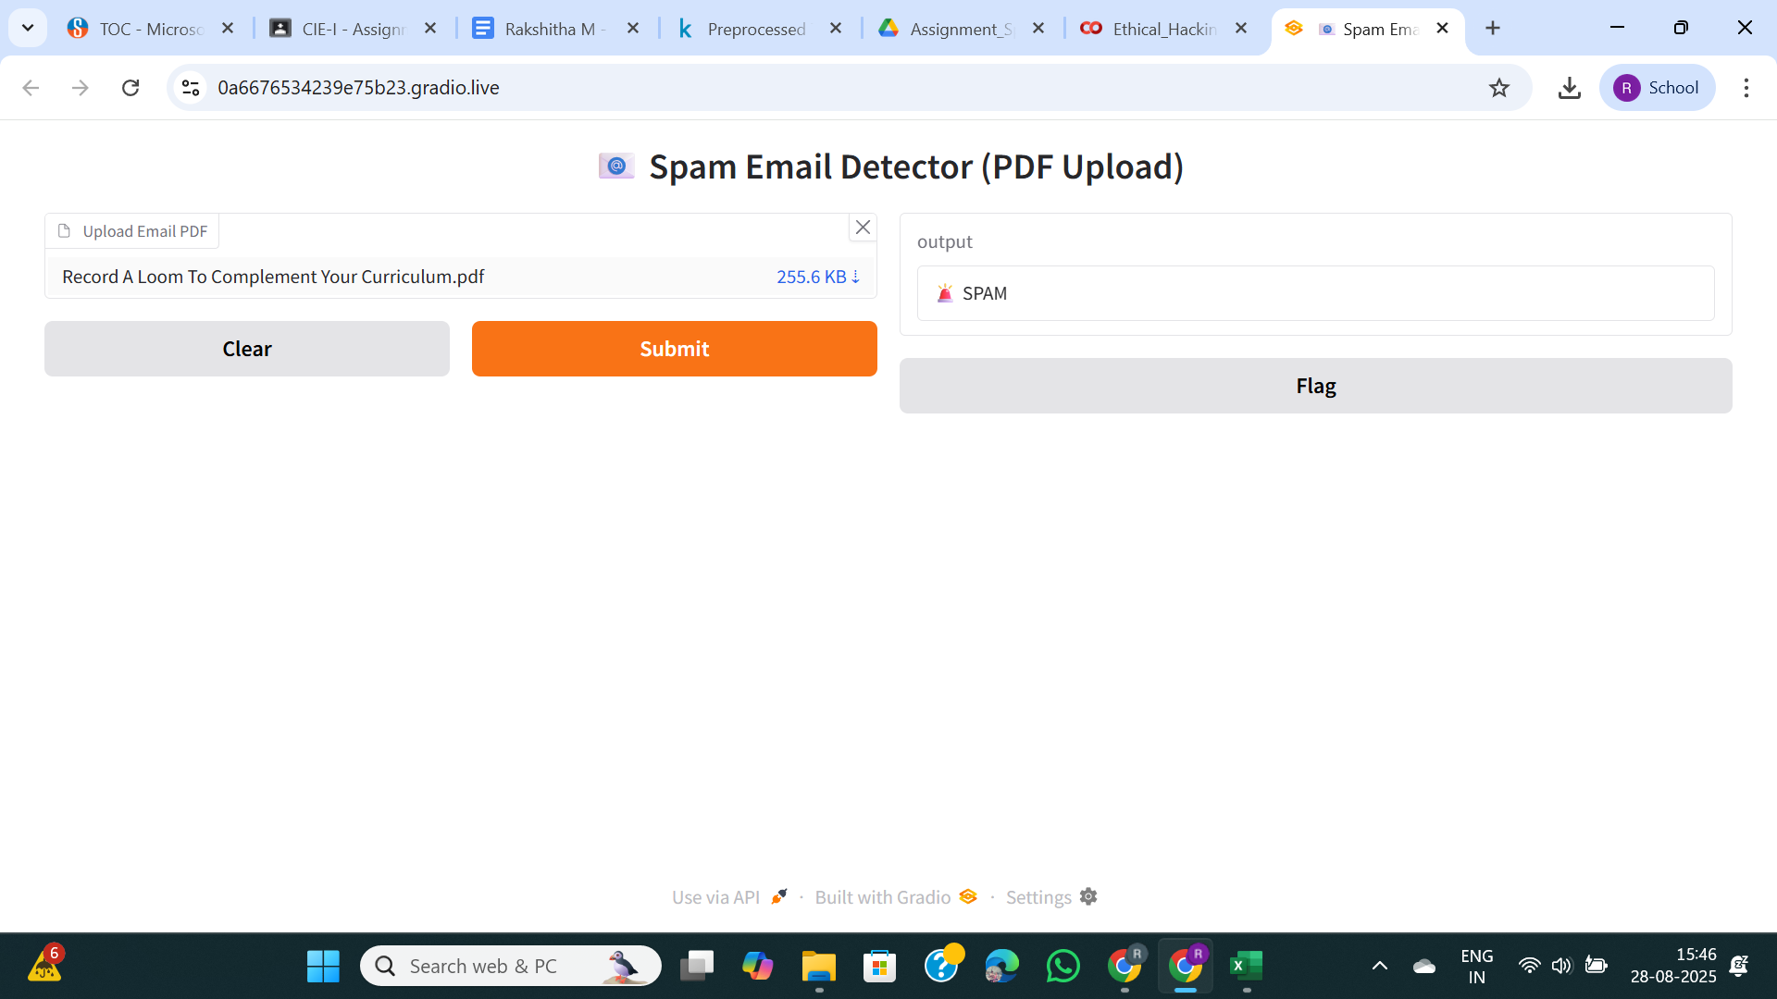
- Gradio web app interface (batch PDF upload with results table).
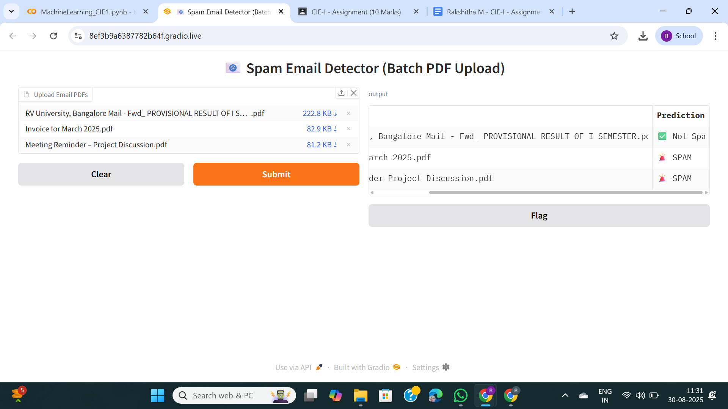

4. Conclusion
This project successfully implemented a Spam Email Detection Web Application. The Logistic regression model achieved ~98% accuracy and was integrated into a simple user-friendly web interface. The application can classify both single and multiple email PDFs effectively.

